Bachelor of Science in Quality for Industry (add-on Level 7) – FREQUENTLY ASKED QUESTIONS
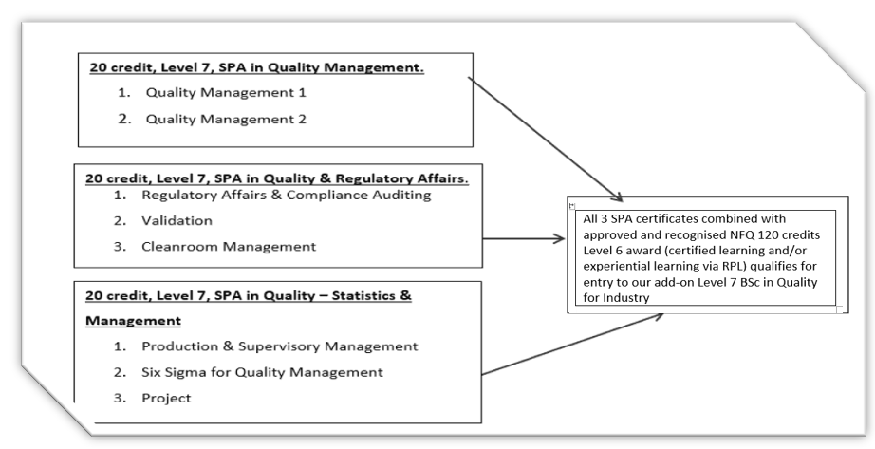

Overview of the Level 7 B Sc Quality for Industry and their embedded certificates.
This programme was created in consultation with Industry based on the need for a focus on quality, regulatory and systems practices in regulated Industries, including MedTech. The programme provides the knowledge to facilitate the upskilling of production operators to Quality Technicians, Engineers and onto Quality Management. This programme particularly supports the skill needs of the growing number of MedTech start-ups/SMEs in the Galway region.

What modules are covered in the BSc in Quality for Industry and when are they on?
Times may vary from year to year. As a guide below is our delivery schedule for last year.

Add-on Level 7 B.Sc. in Quality for Industry
SPA/Certificate in Science in Quality Management
MGMT07045 | QUALITY MANAGEMENT I | YL Tuesday 6.30-9.30pm
MGMT07043 | QUALITY MANAGEMENT II | YL Tuesday 6.30-9.30pm
SPA/Certificate in Science in Quality and Regulatory Affairs
SCIE07008 | CLEAN ROOM MANAGEMENT | S2 Weds 7:00-10.00pm
SCIE07009 | REGULATORY AFFAIRS AND COMPLIANCE AUDITING | YL Monday 6.30-9.30pm
SCIE07010 | VALIDATION | S1 Weds 6.30-9.30pm
SPA/ Certificate in Science in Quality Statistics and Management
MGMT07049 | PRODUCTION AND SUPERVISORY MANAGEMENT | S1 Thurs 6.30-9.30pm
MANU07008 | SIX SIGMA FOR QUALITY MANAGEMENT | S2 Thurs 6.30-9.30pm
MANU07018 | PROJECT LEVEL 7 | S2 mainly-as required
Key: YL is yearlong, S1 is semester one, S2 is semester two.

How are these modules delivered?
The modules are delivered using blended approaches, this means that lecturers employ flexible multi-mode delivery approaches on the days/times listed above. Delivery approaches include a combination of face to face as well as online experiences that align and accommodate the context and topic under instruction.

Do I apply for all of these modules at the same time?
We have a few restrictions that are put in place to facilitate your gradual learning and buildup of knowledge in some key areas. So here is the required learning for certain modules as follows:
- Quality Management 1 must be completed before Quality Management 2
- An awareness of statistics such as that which is gained in Quality Management 1 is required before completing Six Sigma for Quality Management
- Experience of conducting projects such as that gained in Quality Management 1 must be completed before Project module.

How long does it take to do all modules in the add-on BSc level 7?
Most students opt take three years to complete the entire add-on degree programme which typically involves two evening classes a week, however you can take longer than this if your schedule would prefer a lesser weekly load. Most students opt to take three years to complete the programme, but we also have a few students who take the two-year option. Remember that whatever you select, you will need to plan for equal study time beyond the delivery time for continuous assessment and study time.

A suggested three-year suggested pathway
Year 1 QM1, P&SM, Clean Room Management,
Year 2 QM2, RA/CA
Year 3 Six Sigma, Validation, Project

When does this programme start?
The programme/modules start in mid-September. Semester one modules start in mid-September and semester two modules starting in mid-January.

How do I apply for the add-on Level 7 BSc in Quality for Industry?
The add-on level 7 BSc in Quality for Industry is made up of 8 modules. Some of these modules are combined to form a special purpose award/certificate.

For now, you have three options for the application process.
- You can apply for a single module(s) only.
- You can apply for a Special Purpose Award/certificate (which consists of two or three modules)
- You can apply for the full add-on BSc in Quality (which consists of all 8 module) if you have 120 credits of an approved and recognized NFQ Level 6 in Business, Engineering or Science or equivalent.

For all above application options, log on to the applications page and select application type Q7 from the drop-down box in the Application Menu. apply.atugalwaymayo.ie

What is the best application option to take?
It depends on if you plan on continuing your studies. The advantage of applying for more than one module (for example, applying for a certificate or the full degree) is that your place on the subsequent modules is secured.

For applicants who wish to apply for the full add-on BSc in Quality for Industry that don’t have a Level 6 Higher Certificate; can I still apply?
Yes - If you want to apply for the BSc in Quality for Industry and if you don’t hold a full Level 6 Higher Certificate and if you have significant experience in industry, you can support your application to this programme with Recognition of Prior Learning documentation. If you wish to take this route, contact learn.galwaymayo@atu.ie for the Quality RPL information pack.

What is Recognition of Prior Learning (RPL)?
Recognition of Prior Learning (RPL) is a system whereby learning acquired through work experience and/or through previous certified programmes can be acknowledged as a basis for entry to the programmes. You can complete this RPL documentation as part of your application for these programmes. For those interested in applying direct for the BSc in Quality, we have a guidance document to support your application.

Do I need to buy any software/technology for this programme?
ATU provide all students with Microsoft office which hosts outlook for email and TEAMs for any online interactions. All students will be able to avail of the ATU IT induction to get you orientated with these applications. While it would be ideal for you to have access to a computer/laptop, ATU library computers are available for all students of ATU to use during opening hours.

How much does each module cost?
The cost of each module is located on the website along with payment options.

When can I apply for modules?
Online application opens during early April every year and closes typically at the end of August. Early application is advisable as this is a very popular programme.

Who do I contact if I have any more questions?
Learn.galwaymayo@atu.ie is your contact point for all queries.

